**Docker installation in ubuntu**

**Installing Docker**

**Step1:** First, update your existing list of packages

**sudo apt update**

**Step2:** Next, install a few prerequisite packages which let apt use packages over HTTPS:

**sudo apt install apt-transport-https ca-certificates curl software-properties-common**

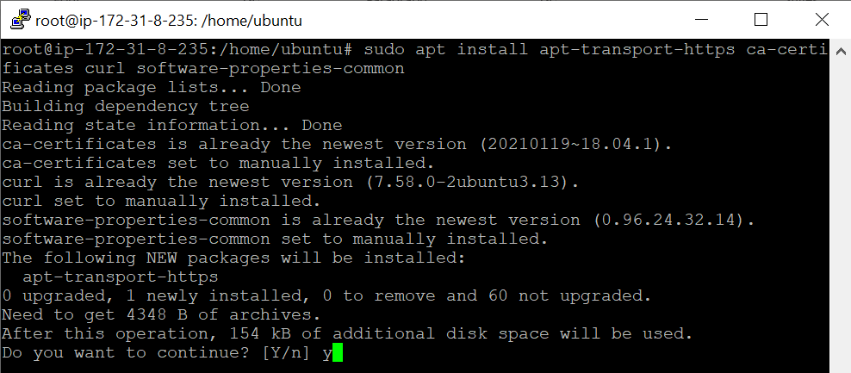

**Step3:** Then add the GPG key for the official Docker repository to your system:

**curl -fsSL https://download.docker.com/linux/ubuntu/gpg | sudo apt-key add –**



**Step4:** Add the Docker repository to APT sources:

**sudo add-apt-repository "deb [arch=amd64] https://download.docker.com/linux/ubuntu bionic stable"**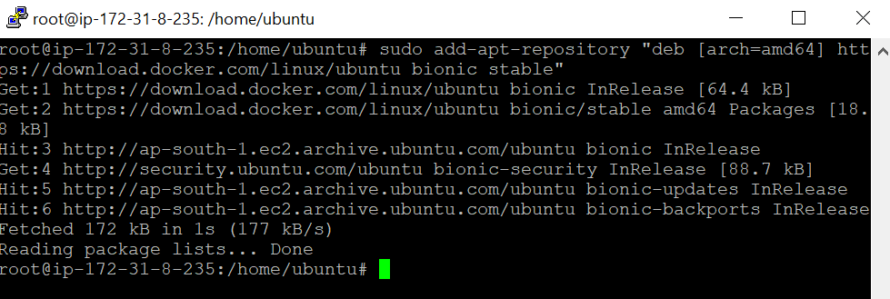

**Step5:** Next, update the package database with the Docker packages from the newly added repo:

**sudo apt update**

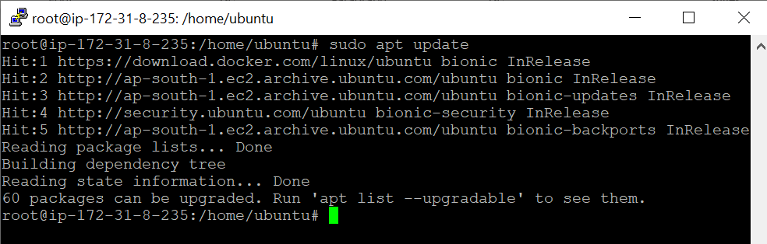

**Step6:** Make sure you are about to install from the Docker repo instead of the default Ubuntu repo:

**apt-cache policy docker-ce**

**Step7:** Finally, install Docker:

**sudo apt install docker-ce**

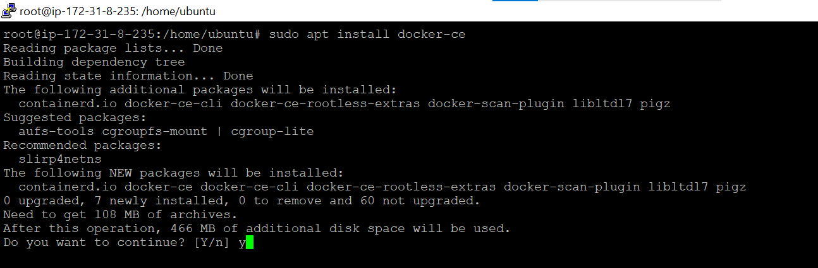

Docker should now be installed, the daemon started, and the process enabled to start on boot. Check that it’s running:

**sudo systemctl status docker**

